|  |
| --- |
| Med health laboratories limited |
| SCC Kiosk |
| Patient registration and wait times    Software manual |
| Version 1.0  All work Copyright © 2018 by Med Health Laboratories Limited.  All rights reserved. |
| **Anant Prajapati** |
|  |

|  |
| --- |
| June 29, 2018 |

**Table of Contents**

Version History………………………………………………………………………………………………………..…………………3

Application Overview…………………………………………………………………………………………………………………4

Application Mechanics…………………………………………………………………………………………….……………….4

Barcode Scanner..………………………………………………………………………………………………………………………5

Controls………………………………………………………………………………………………………………….….………………5

Saving and Loading………………………………………………………………………………………………….…………………5

Menu and Screen Description………………………………………………………………………………….………………..5

Scenarios………………..………………………………………………………………………………………………………………….8

Application work flows…….……………………………………………………………………………………..……………….10

Buttons…………………………………………………………………………………………….……………………..………………10

Extended export buttons………………………………………………………………………………………………………….11

Steps…………………………………….………………………………………………………………………………………………….11

Adding comments………….………………………………………………………………………………………..………………11

Access Levels……………………………………………………………………………………………………………………………11

Design notes………………………………………………………………………………………………………………….…………11

Future features…………..…………………………………………………………….……………………………..………………11

Design Notes………………….…………………………………………….………………….………………………………………11

Future Features…………….…………………………………………………………………………………………………………11

Links………………………………………………………………………………………………….………….…………………………11

**Version History**

|  |  |  |
| --- | --- | --- |
| **Date** | **Version** | **History** |
| June 27, 2018 | Version 1.0 | Implemented at SCC 450 |
| July 13, 2018 | Version 1.0 | Implemented at SCC 514 |
|  |  |  |
|  |  |  |
|  |  |  |

1. **Application Overview**

*Specimen collection center Kiosk application allows laboratory administrator to monitor patient wait times (PWT) measurement and generate different statistics.*

1. **Application Mechanics**

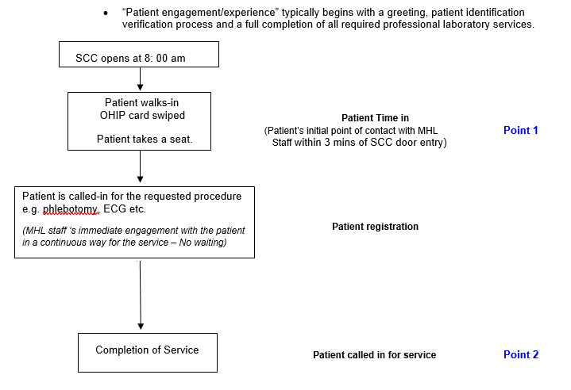

*Patient wait time should initially focus on 2 primary measurement points – patient’s initial point of contact and when the patient receives service:****Point 1*** *is the patient’s initial point of contact. This point represents the first interaction of the patient with lab personnel - All labs have committed that this will start no longer than 3 minutes after the patient crosses the SCC door.*

***Point 2*** *is the time that the patient receives service. This point is defined by the moment the patient is called to service and the phlebotomist or technician has engaged with the patient in a continuous way for the service - This point may be different from the time when the patient is called for service in a situation where the patient is left unattended in a service room. The PWT measure is complete when the phlebotomist or technician is engaging with the patient in providing service in a continuous way.*

**Point 2 (Service Time) minus Point 1 (Scan Time) = wait time for MHL service**

1. **Barcode Scanner**

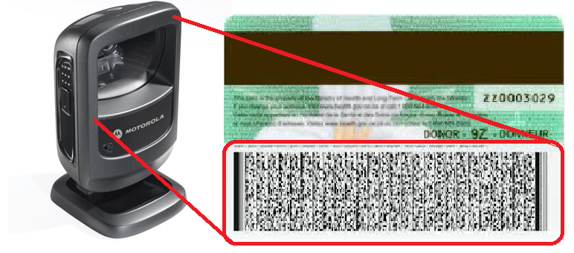

*Barcode Scanner provides an effortless way to enter all required date from OHIP card without manually typing anything.*

1. **Controls**

*User can control with mouse and keyboard.*

1. **Barcode Configuration**

*Type of OHIP barcode is PDF417, decoded to get the form fields recorded.*

*123 Scan2 utility application is used for configuring the barcode scanner. Name of the file is* ***Barcode Configuration Ver 4.scncfg***

*Scanner reads below Fields:*

1. *OHIP*
2. *Name*
3. *Birth Date*
4. *Expiry Date*
5. *Version Code*

*Configuration file is attached with development files.*

OHIPScanner2 - Scanner Parameter Settings Report DS9208

|  |
| --- |
| **Summary Information** |

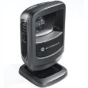

|  |
| --- |
|  |



|  |
| --- |
|  |
|  | |

|  |  |
| --- | --- |
| Report Type:    Configuration name in Utility:    Last Modified:    Windows Filename:    Plug-in Name:    Notes: | Only parameters changed from defaults shown    OHIPScanner2    30-May-18    Barcode Configuration Ver 4.scncfg    DS9208-COMMON SR MODELS-024 |

**Modify Data - Advanced Data Formatting**

|  |
| --- |
|  |

|  |  |
| --- | --- |
|  | *Erase All Rules* |

|  |  |
| --- | --- |
| Rule 1: Unknown Rule 1 |  |

|  |  |
| --- | --- |
|  | *Begin New Rule* |

|  |  |
| --- | --- |
|  | *1. Skip Ahead <20>* |

|  |  |
| --- | --- |
|  | *2. Send Next <10>* |

|  |  |
| --- | --- |
|  | *3. Send Extended Key <Tab>* |

|  |  |
| --- | --- |
|  | *4. Send Up to<NUL> Null char* |

|  |  |
| --- | --- |
|  | *5. Send Extended Key <Tab>* |

|  |  |
| --- | --- |
|  | *6. Move Past a<NUL> Null char* |

|  |  |
| --- | --- |
|  | *7. Send Next <4>* |

|  |  |
| --- | --- |
|  | *8. Send ASCII Key <->* |

|  |  |
| --- | --- |
|  | *9. Send Next <2>* |

|  |  |
| --- | --- |
|  | *10. Send ASCII Key <->* |

|  |  |
| --- | --- |
|  | *11. Send Next <2>* |

|  |  |
| --- | --- |
|  | *12. Send Extended Key <Tab>* |

|  |  |
| --- | --- |
|  | *13. Skip Ahead <9>* |

|  |  |
| --- | --- |
|  | *14. Send Next <4>* |

|  |  |
| --- | --- |
|  | *15. Send ASCII Key <->* |

|  |  |
| --- | --- |
|  | *16. Send Next <2>*  *17. Send ASCII Key <->*  *18. Send Next <2>*  *19. Send Extended Key <Tab>*  *20. Skip Ahead <2>*  *21. Send Next <2>*  *22. Send Extended Key <Enter>*  *Save Rule* |

1. **Saving and Loading**

*The application saves and load data tables automatically. Application uses MySQL database [SCC PWT]. Exported stats and tables are available to see on L:\SCC Wait Times.*

*MySQL*

|  |  |  |
| --- | --- | --- |
| ***SCC*** | ***Database*** | ***Table*** |
| *Location 101* | *scc_pwt* | *scc101* |
| *Location 201* | *scc201* |
| *Location 450* | *scc450* |
| *Location 470* | *scc470* |
| *Location 514* | *scc514* |

1. **Menu and Screen Descriptions**

Application main page has a DataTable and buttons which look like below screenshot.

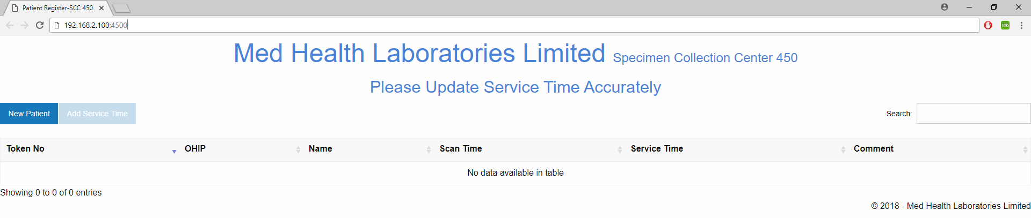

**Menu Screen**

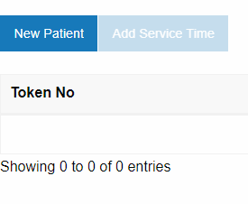

**New Patient Button**

*Registration form of patient.*

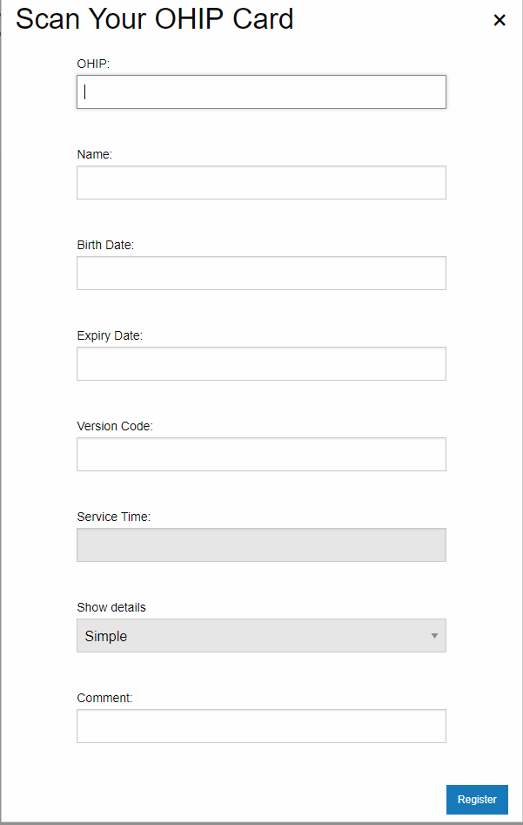

**Registration Form**

1. **Scenarios**

***Scenario 1****: When OHIP is scanned, all the form fields will be filled automatically. If OHIP is not available, then reception staff must do the manual entry.*

***Scenario 2****: Red & White health card does not have a version code, in that case staff puts ‘XX’ in that field.*

***Scenario 3****: Cash patient, OHIP number ‘999’ and version code ‘XX’, other details as it is.*

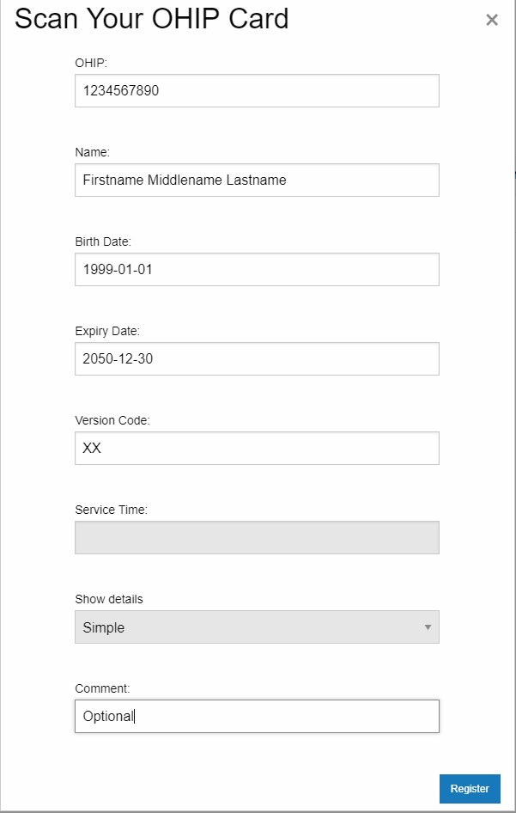

**Barcode scanned form**

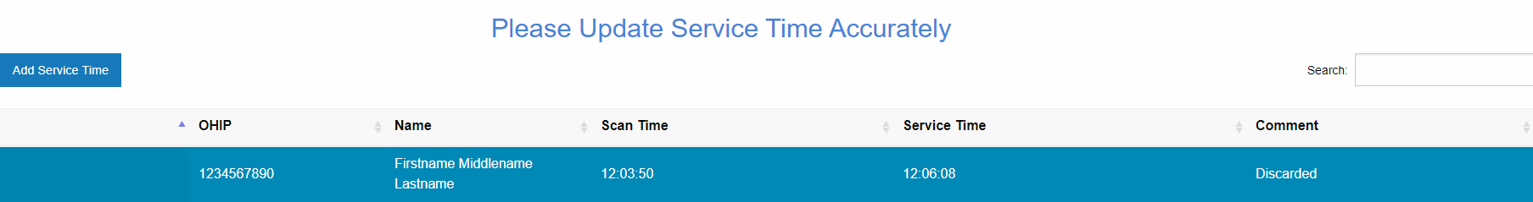

**Adding Service Time Button**

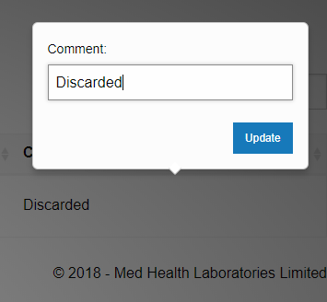

**Adding Comment Button**

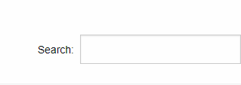

**Search box to find any fields from columns**

1. **Application work Flow**

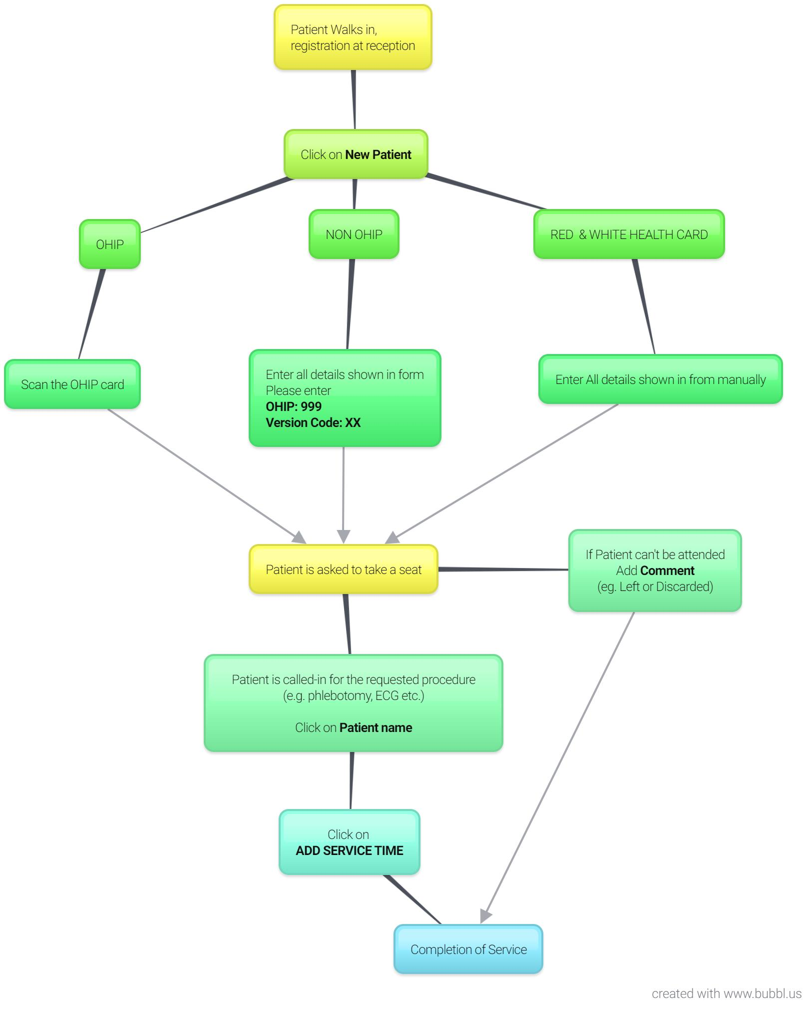

1. **Buttons**

*New*

*Edit [accessible to Admin only]*

*Delete [accessible to Admin only]*

*Export [accessible to Admin only]*

*Add Service Time*

1. **Extended Export Buttons [Admin only]**

*Copy*

*Excel*

*CSV*

*PDF*

*Print*

1. **Steps**

Step 1- Click New Patient

Step 2- Scan OHIP

Step 3- Add Service Time

1. **Adding Comments**

*Adding comment on entries is an optional, and for the records of an exception. For example, if the patient is left without service or can not perform any tests, then staff can add description in comment section. E.g., Left, Discarded, Expired health card, etc.*

1. **Access Levels**

***Kiosk [port]:*** *Minimum access. [New Patient Button only]*

***Reception [port]:*** *Limited access. [New Patient, Add Service Time, Add Comment]*

***Admin [port]:*** *Full access. [All access]*

1. **Design Notes**

Data Tables Editor Generator V 1.7

1. **Future Features**

*Expiry date validation, export report range, Login/out.*

1. **Links**

|  |  |  |
| --- | --- | --- |
| **Location** | **Set up** | **192.168.2.100: Port** |
| 450 | Kiosk | 450 |
| Reception | 4500 |
| Admin | 4501 |
| 514 | Kiosk | 5142 |
| Reception | 5140 |
| Admin | 5141 |
| 101 | Kiosk | 1012 |
| Reception | 1010 |
| Admin | 1011 |
| 201 | Kiosk | 2012 |
| Reception | 2010 |
| Admin | 2011 |
| 470 | Kiosk | 4702 |
| Reception | 4700 |
| Admin | 4701 |
| 474 | Kiosk | 4742 |
| Reception | 4740 |
| Admin | 4741 |